**Ideation Phase**

**Define the Problem Statements**

|  |  |
| --- | --- |
| Date | 11 October 2022 |
| Team ID | PNT2022TMID12047 |
| Project Name | Project – Car resale value prediction |
| Maximum Marks | 2 Marks |

**Customer Problem Statement Template:**

The main aim of this project is to predict the price of used cars using the various Machine Learning (ML) models. This can enable the customers to make decisions based on different inputs or factors namely

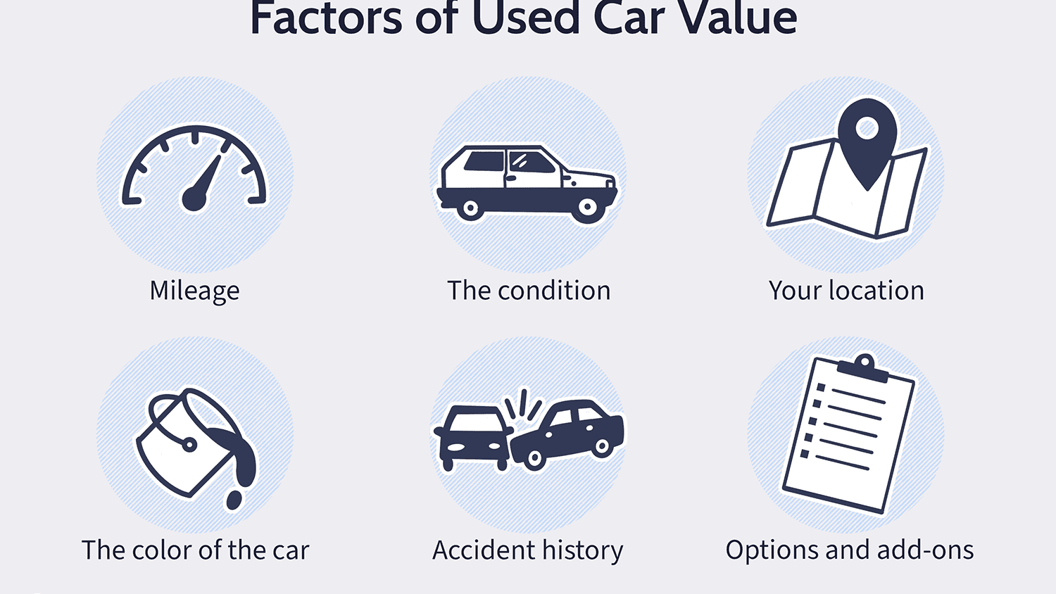

to name a few characteristic features required by the customer. The project Car Price Prediction deals with providing the solution to these problems. Through this project, we will get to know which of the factors are significant and tell us how they affect the car’s worth in the market

The dataset has the folloing columns which has details of

* Unique ID, where no two cars can have same ID
* Region where the car is available
* Price of the car which also includes the price range
* Year of manufacture like 2020, 2021 etc
* Brand or Type of the car
* Name of the manufacturer
* Model of the car

to name a few. These are the primary needs the customer looks into before buying a second hand car. We can also add some additional features that can enhance the chances of the customer and also helps in the sales of the cars

